
Fast RTPS

Latency Test

eProsima
Proyectos y Sistemas de Mantenimiento SL
Ronda del poniente 16 – Bajo K
28760 Tres Cantos Madrid
Tel: + 34 91 804 34 48
info@eProsima.com – www.eProsima.com
Trademarks
eProsima is a trademark of Proyectos y Sistemas de Mantenimiento SL. All other trademarks used in this document are the property of their respective owners.
License
eProsima Fast RTPS is licensed under the terms described in the FASTRTPS_LIBRARY_LICENSE.txt file included in this distribution.
Technical Support
Phone: +34 91 804 34 48
Email: Support@eProsima.com

Contents
1. Introduction 1
1.1. Latency 1
2. Latency Test 2
2.1. Source Files 2
2.2. Building the test 2
2.3. Test operation 2
2.3.1. Command line options 3
2.3.2. Command line examples 3
2.4. Test results 4

Introduction
This document provides instructions on using the eProsima Fast RTPS latency test example, which is provided in source code.

Latency
The latency is usually defined as the amount of time a message takes to traverse a system. In a packetbased network the latency is usually measured either as the one-way latency (the time from the source sending the packet to the destination receiving it) or as the round-trip delay time (the time from source to destination plus the time from the destination back to the source). The latter is more often used since it van be measured from a single point.
In the case of a RTPS communication exchange the latency could be defined as the time it takes a publisher to serialize and send a data message plus the time it takes a matching subscriber to receive and de-serialize it. Applying the same round-trip concept mentioned before, the round-trip latency could be defined as the time it takes a message to be sent by a publisher, received by a subscriber and sent back to the same publisher. An example of this measurement methodology can be observed in next figure, where the round trip latency can be obtained from T2-T1.
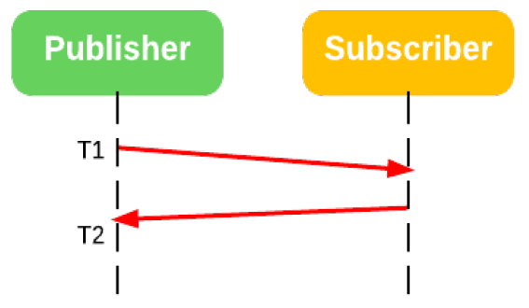
Latency can also be computed for a multiple subscriber environment, as shown in next figure, where the round trip latency would be T2-T1.
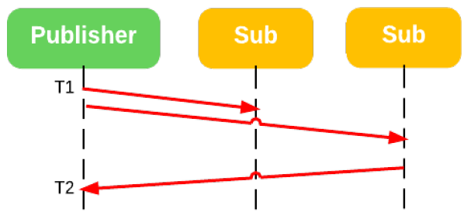

Latency Test
The latency test distributed with this release of eProsima Fast RTPS is developed to be able to determine the round trip latency of different scenarios involving a single publisher and one or multiple subscribers. The following sections will explain the test operation and its results.

Source Files
The Latency test distributed with this release of eProsima RTPS consist of the following source files:
• LatencyTestTypes.cpp/.h: Serialization and deserialization method of the two data types used in the test: LatencyType (the one sent in the latency test) and CommandType (a specific data used by the endpoints to communicate the beginning of the test).
• LatencyTestPublisher.cpp/.h: This class contains the publisher side of the application. Two DDS publishers and subscribers are created (a pair for the latency data communication and a pair for the commands). This class is also in charge of saving the times and calculating the time statistics.
• LatencyTestSubscriber.cpp/.h: This class contains the subscriber side of the application. As in the publisher side two pairs of publisher/subscriber are created to perform the test.
• main_LatencyTest.cpp: This is the main file of the application that creates a LatencyTestPublisher or a LatencyTestSubscriber depending on the command line options.

Building the test
A current version of eProsima RTPS library needs to be installed and compiled to be able to build and execute the test.
If you have downloaded the Fast RTPS github repository, the latency test will compile with cmake and will generate two executable files: LatencyTest and LatencyTestd, one for the release and one for the debug version of the test. To obtain reliable results the release version should be used. Boost 1.57 needs to be installed on the system.

Test operation
The same application file is used in either side of the test (publisher or subscriber). The behavior of the test will depend on the command line arguments provided to the application.

Command line options
A number of arguments can be passed to the application.
The first one is publisher/subscriber. This first argument indicates the application whether is going to be acting as the publisher side or the subscriber side in this test.
In case the first argument is publisher, the following arguments can be:
Option | Meaning
-h [ --help ] | Outputs the help message
-r [ --reliability ] arg | Reliability of the participant. Can be reliable or besteffort.  Default: besteffort.
-n [ --subscribers ] arg | Number of subscribers.  Default: 1.
-s [ --samples ] arg | Number of samples to send.  Default: 10000.
--seed arg | Numeric seed to compute domain and topic. Used to isolate the test.  Default: 80.
In case the first argument is subscriber, the following arguments can be:
Option | Meaning
-h [ --help ] | Outputs the help message
-r [ --reliability ] arg | Reliability of the participant. Can be reliable or besteffort.  Default: besteffort.
-e [ --echo ] arg | Echo mode. Can be true or false.  Default: true.
-s [ --samples ] arg | Number of samples to expect.  Default: 10000.
--seed arg | Numeric seed to compute domain and topic. Used to isolate the test.  Default: 80.

Command line examples
The following table present two examples of command line options for two different tests.
One to one test: | Command
Publisher: | LatencyTest publisher -n 1 -s 10000
Subscriber: | LatencyTest subscriber -e true -s 10000
One to multiple test:
Publisher: | LatencyTest publisher --subscribers 2 --samples 10000
Subscriber 1: | LatencyTest subscriber --echo false --samples 10000
Subscriber 2: | LatencyTest subscriber --echo true --samples 10000

Test results
The results are measured in the publisher side and expressed in microseconds. An example of the obtained results can be seen below:
Printing round-trip times in us, statistics for 10000 samples
Bytes, Samples, stdev, mean, min, 50%, 90%, 99%, 99.99%, max
--------,--------,--------,--------,--------,--------,--------,--------,--------,--------
16, 10000, 18.00, 80.28, 29.52, 76.30, 90.79, 133.51, 642.29, 657.08
32, 10000, 25.00, 81.78, 28.91, 76.61, 92.30, 132.30, 1088.44, 1258.68
64, 10000, 17.00, 79.86, 30.72, 76.61, 88.38, 129.73, 616.93, 662.21
128, 10000, 19.00, 80.36, 30.42, 76.91, 90.49, 135.47, 811.63, 959.54
256, 10000, 17.00, 81.83, 27.40, 77.21, 93.51, 139.70, 628.25, 812.54
512, 10000, 16.00, 80.58, 29.21, 77.21, 90.19, 133.81, 616.33, 670.97
1024, 10000, 17.00, 103.92, 93.81, 97.74, 125.21, 158.71, 620.10, 647.12
2048, 10000, 14.00, 107.48, 96.23, 101.06, 126.72, 161.28, 338.17, 372.73
4096, 10000, 39.00, 118.00, 102.87, 108.91, 138.19, 198.71, 1985.86, 3260.31
8192, 10000, 30.00, 128.69, 94.11, 117.96, 151.47, 221.35, 951.54, 1057.34
16384, 10000, 11.00, 149.42, 140.30, 145.43, 158.71, 194.63, 356.43, 378.16

